JSON Syntax Rules

🌟 What is JSON Syntax?
# Source: AI Source: Provided by: [Data Path: Persons Table -> ID Column: 1, Name_En Column: Motasem Essam] -> From: [ChatGPT] on [5/31/2026]
JSON Syntax is the set of rules that defines how JSON must be written correctly so that computers can read and understand it.
If the syntax is wrong → the JSON becomes invalid.

🧾 Syntax Rules

📚 1. Keys Must Use Double Quotes
# Source: AI Source: Provided by: [Data Path: Persons Table -> ID Column: 1, Name_En Column: Motasem Essam] -> From: [ChatGPT] on [5/31/2026]
✔ Correct:
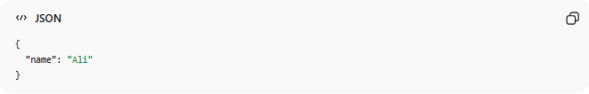
{
"name": "Ali"
}
❌ Wrong:
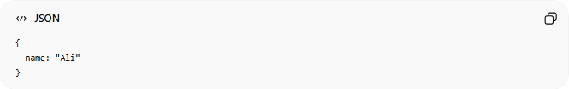
{
name: "Ali"
}

📚 2. Values Must Follow Correct Data Types
# Source: AI Source: Provided by: [Data Path: Persons Table -> ID Column: 1, Name_En Column: Motasem Essam] -> From: [ChatGPT] on [5/31/2026]
Allowed:
- String
- Number
- Boolean
- Null
- Object
- Array

📚 3. No Trailing Commas
# Source: AI Source: Provided by: [Data Path: Persons Table -> ID Column: 1, Name_En Column: Motasem Essam] -> From: [ChatGPT] on [5/31/2026]
✔ Correct:
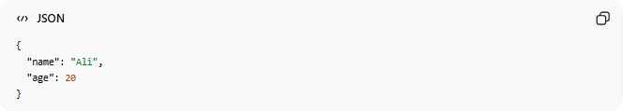
{
"name": "Ali",
"age": 20
}
❌ Wrong:
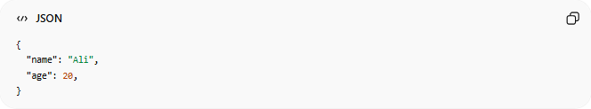
{
"name": "Ali",
"age": 20,
}

📚 4. Strings Must Use Double Quotes
# Source: AI Source: Provided by: [Data Path: Persons Table -> ID Column: 1, Name_En Column: Motasem Essam] -> From: [ChatGPT] on [5/31/2026]
✔ Correct:
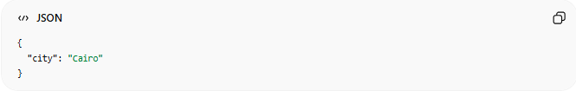
{
"city": "Cairo"
}
❌ Wrong:
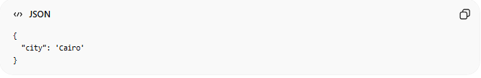
{
"city": 'Cairo'
}

📚 5. JSON Must Be Valid Structure
# Source: AI Source: Provided by: [Data Path: Persons Table -> ID Column: 1, Name_En Column: Motasem Essam] -> From: [ChatGPT] on [5/31/2026]
JSON must always be:
- One object { } OR
- One array [ ]
✔ Correct:
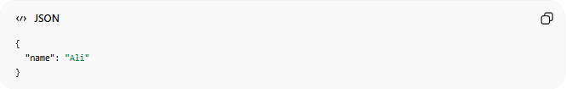
{
"name": "Ali"
}

📚 6. No Functions Allowed
# Source: AI Source: Provided by: [Data Path: Persons Table -> ID Column: 1, Name_En Column: Motasem Essam] -> From: [ChatGPT] on [5/31/2026]
❌ Not allowed in JSON:
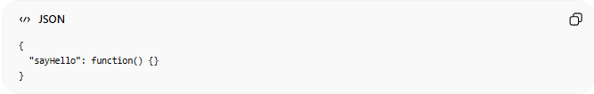
{
"sayHello": function() {}
}

📚 7. No Comments Allowed
# Source: AI Source: Provided by: [Data Path: Persons Table -> ID Column: 1, Name_En Column: Motasem Essam] -> From: [ChatGPT] on [5/31/2026]
❌ Invalid JSON:
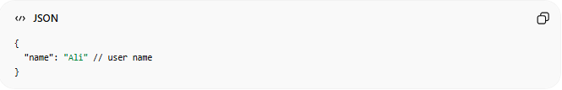
{
"name": "Ali" // user name
}

📚 8. Case Sensitivity
# Source: AI Source: Provided by: [Data Path: Persons Table -> ID Column: 1, Name_En Column: Motasem Essam] -> From: [ChatGPT] on [5/31/2026]
JSON is case-sensitive:
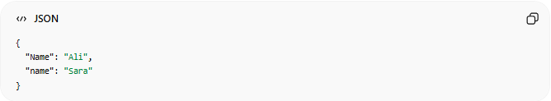
{
"Name": "Ali",
"name": "Sara"
}
These are two different keys.

🧠 Simple Idea
# Source: AI Source: Provided by: [Data Path: Persons Table -> ID Column: 1, Name_En Column: Motasem Essam] -> From: [ChatGPT] on [5/31/2026]
Think of JSON syntax like:
📦 Rules for packing a delivery box
If you break the rules → the box cannot be shipped.

⚠️ Common Errors
# Source: AI Source: Provided by: [Data Path: Persons Table -> ID Column: 1, Name_En Column: Motasem Essam] -> From: [ChatGPT] on [5/31/2026]
- Missing quotes
- Extra commas
- Wrong brackets
- Invalid data types
- Using comments

🧭 Summary
# Source: AI Source: Provided by: [Data Path: Persons Table -> ID Column: 1, Name_En Column: Motasem Essam] -> From: [ChatGPT] on [5/31/2026]
JSON syntax rules ensure that data is written in a strict and valid format using double quotes, correct structure, and proper values so that machines can reliably read and process it.

